

Auto Mapper

Setup follwing Wade

Leaders | Leads Project | 12 Dec 2018

# Setup

Nuget Packages:

* Install-Package AutoMapper.Extensions.Microsoft.DependencyInjection

Startup.cs (ConfigureServices):

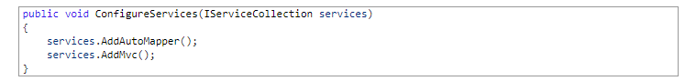

Adding Profiles:

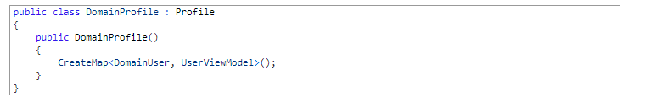

Using IMapper:



Scopes

* Automapper profiles are singletons.
* The IMapper interface is scoped.
  + For every individual request, a new IMapper is created but then shared across the entire app for that whole request.
  + So if you use IMapper inside a controller and inside service for a single request, they will be using the same IMapper instance
* What is really important, is that anything that derives from IValueResolver, ITypeConverter or IMemberValueResolver will be of transient scope.
  + They will also be created using the .NET Core Service Collection DI.
  + To following code that may be used to resolve a particular mapping whereby you want to map across a username based on the source models “Id”.

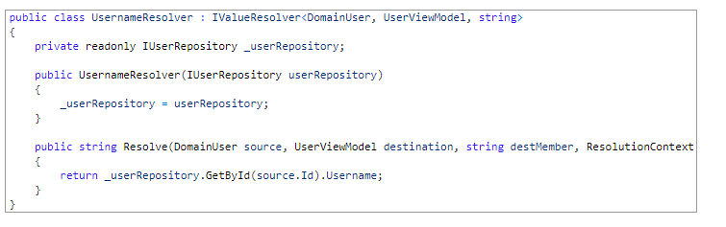

# Reference

.Net Core Tutorials:

* https://dotnetcoretutorials.com/2017/09/23/using-automapper-asp-net-core/